# Prediction of Single Image

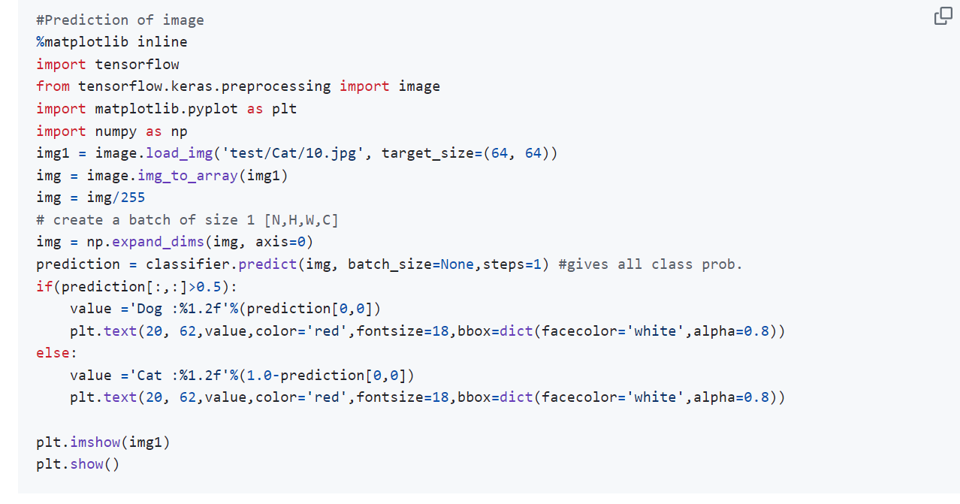

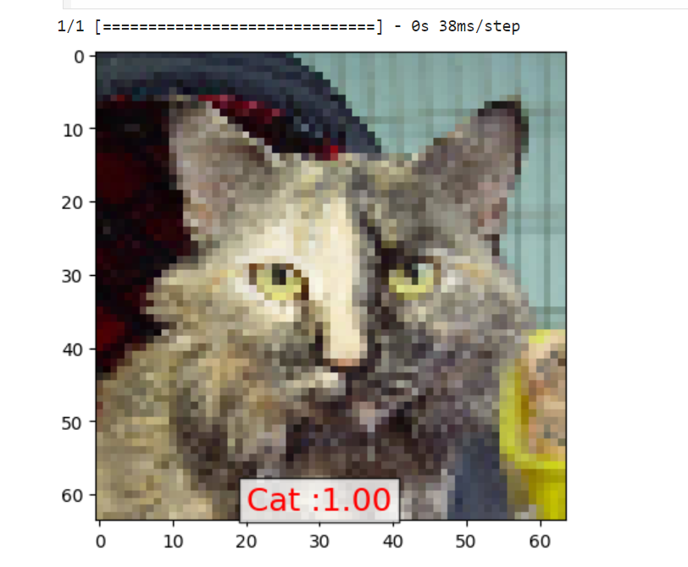

use a trained model to predict labels for a test set of images and then create a DataFrame to store the filenames, predicted probabilities, and true labels. However, there are a few issues in your code that need to be addressed.

Here is the corrected and complete example:

1. **Load the Test Set**: Use ImageDataGenerator to create a generator for the test set.
2. **Make Predictions**: Use the predict method of the model (note that predict_generator is deprecated in newer versions of TensorFlow).
3. **Create the DataFrame**: Store the filenames, predicted probabilities, and true labels in a DataFrame.

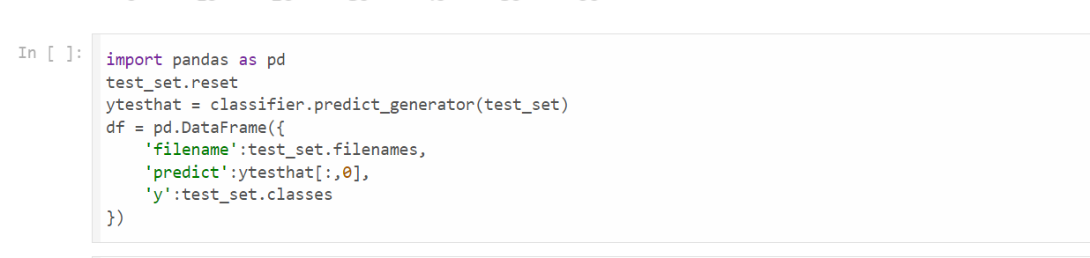

the display of floating-point numbers in your DataFrame, create a binary prediction column based on a threshold, and display the first 100 rows of the DataFrame. Here’s how you can do that:

1. **Set Display Format**: Format the floating-point numbers to five decimal places.
2. **Create Binary Prediction Column**: Convert predicted probabilities to binary values using a threshold (0.5 in this case).
3. **Display the DataFrame**: Show the first 100 rows of the DataFrame.

